Lab Exercise

Course Name | REXX Programming
Module Name | Compound Variables and Subroutines
Topic Name | Topic 3 – Subroutines, Topic 4 - Functions
Exercise Name | Exercise 1 – Subroutines and Functions
Objectives | At the end of the exercise, you should be able to:  - Use internal, internal procedural, and external subroutines  - Invoke functions
Problem Statement/Scenario | Create a REXX program that should:  - Accept two numbers as input from the user  - Have a subroutine that would find the average of these two numbers  - Execute the subroutine as an internal subroutine  - Execute the subroutine as an internal procedural subroutine  - Execute the subroutine as an external subroutine  - Execute the subroutine as an external function
Solution | Use the PULL command to receive two numbers from the user.
Technical Requirements | The Mainframe REXX interpreter should be available.

Step 1 | Finding the average of two numbers using an internal subroutine:  Scope of variables A and B are global and there is no need to pass them as arguments. Similarly, variable C created in subroutine AVG can be accessed in the main flow, and it need not be returned from the subroutine.  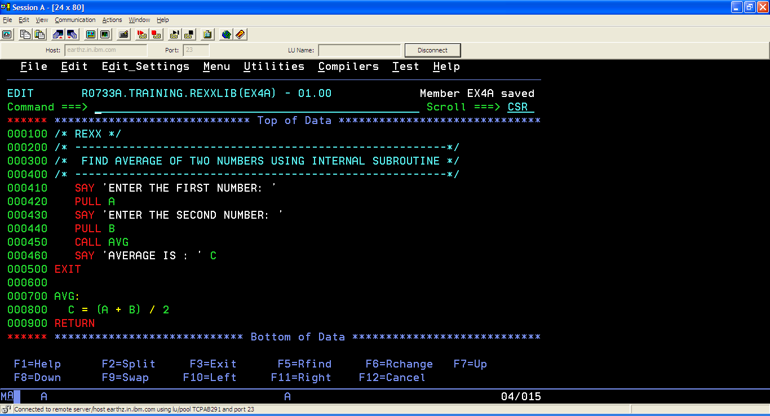  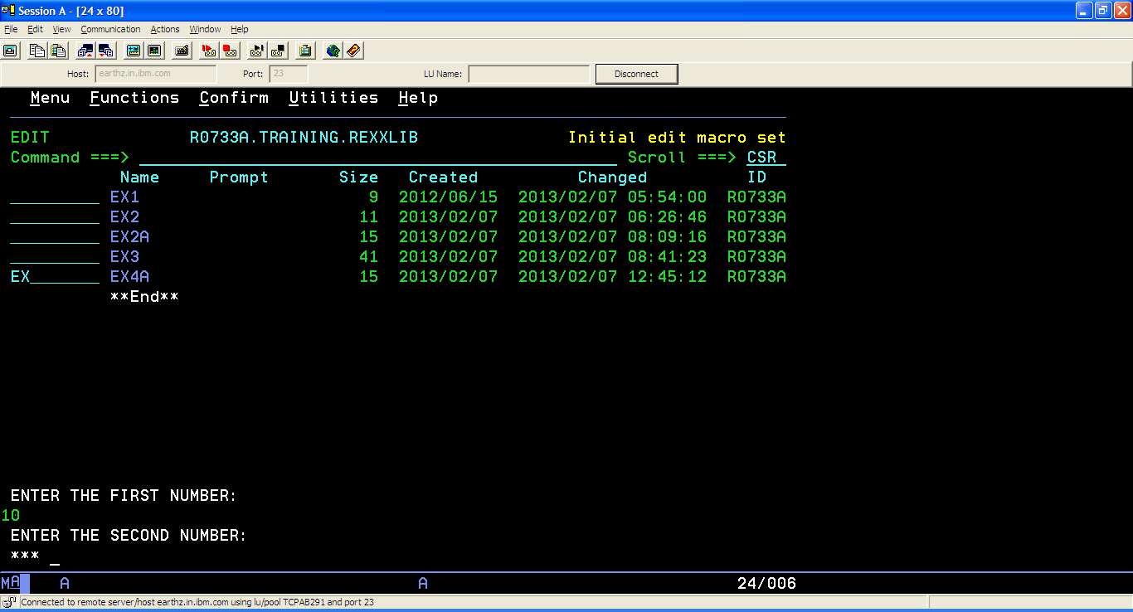  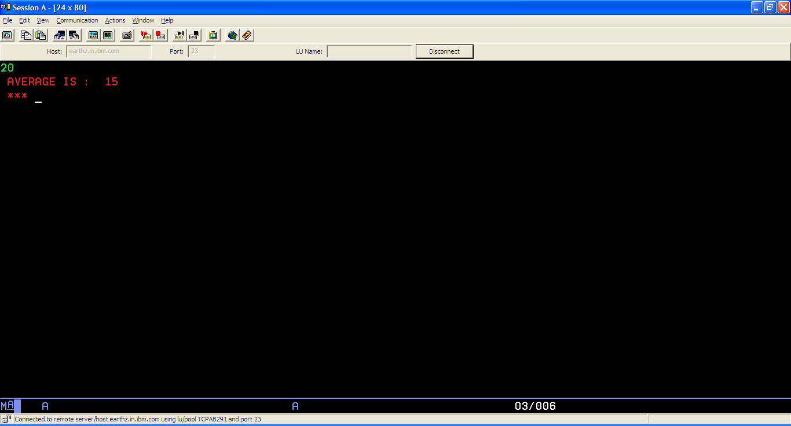

Finding the average of two numbers using an internal procedural subroutine:

Scope of variable A is local to the main module and it needs to be passed as an argument. Variable B is exposed in the procedural subroutine using the EXPOSE keyword and hence need not be passed as an argument. Variable C created in the subroutine cannot be accessed in the main module and its value has to be passed to the main module using RETURN. The value returned by the subroutine is accessed in the main stream by accessing the special variable RESULT.

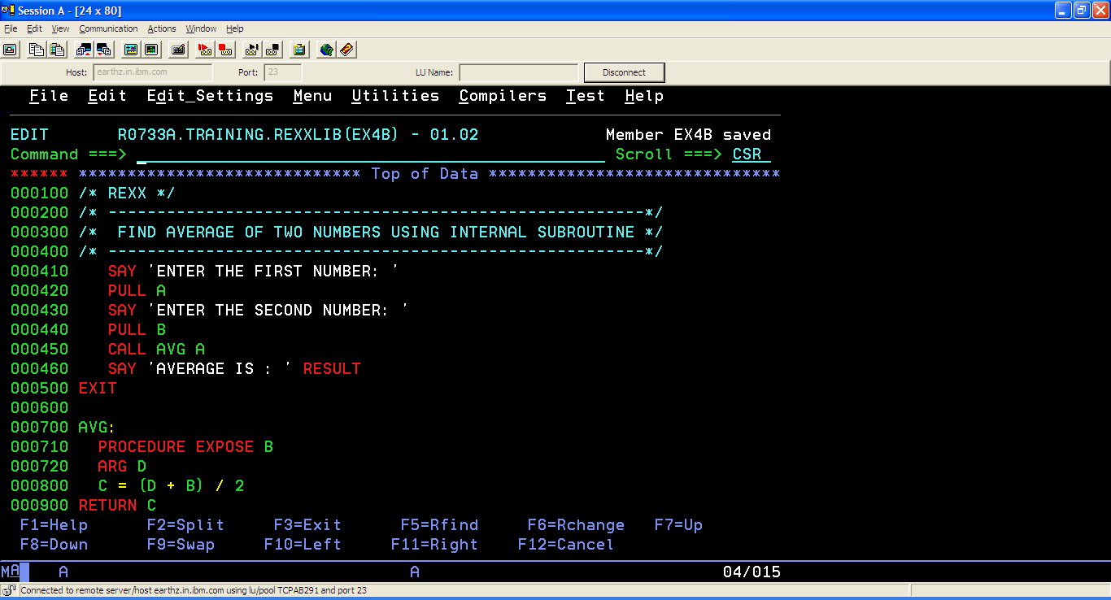

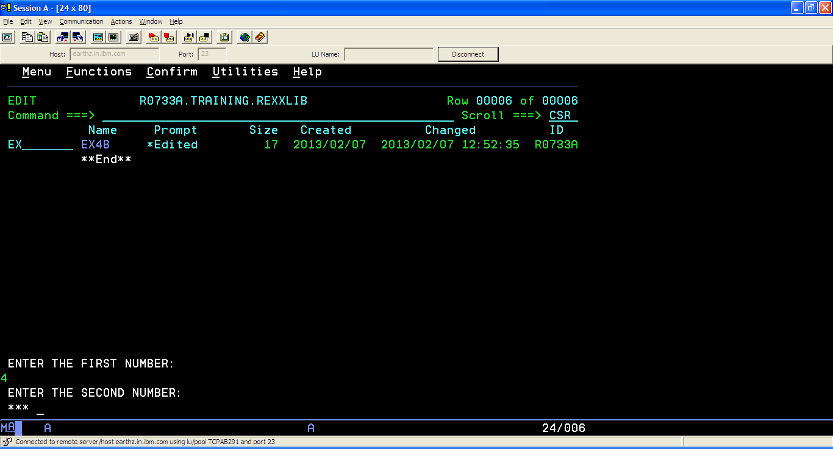

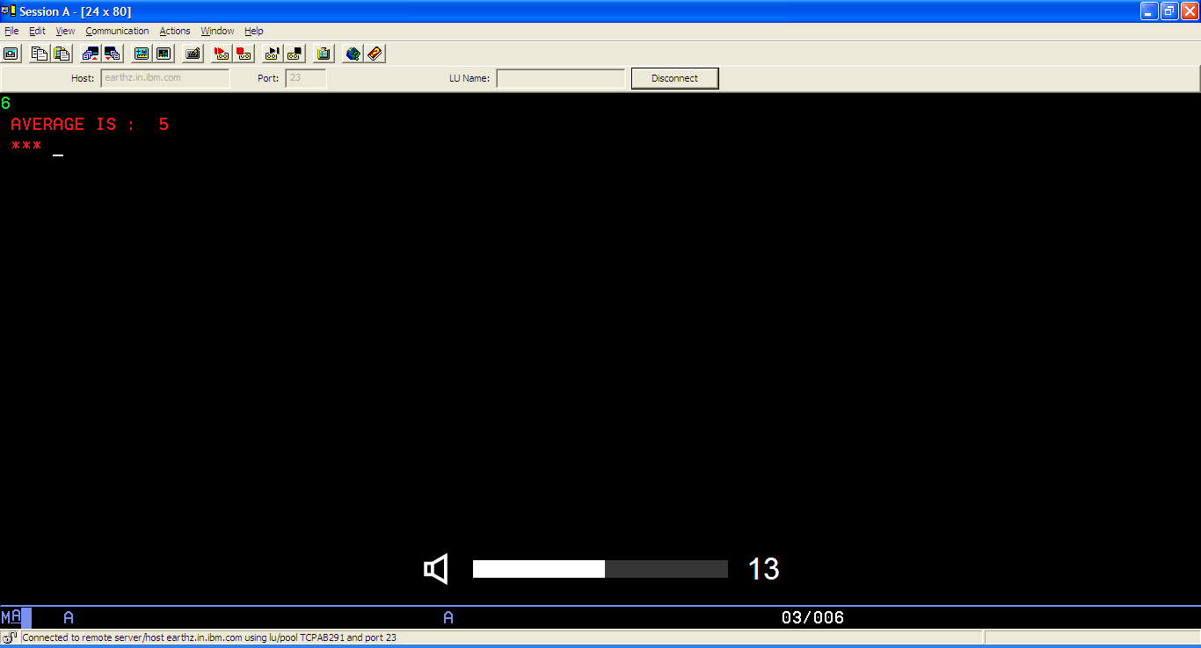

Finding the average of two numbers using an external subroutine:

Main Module:
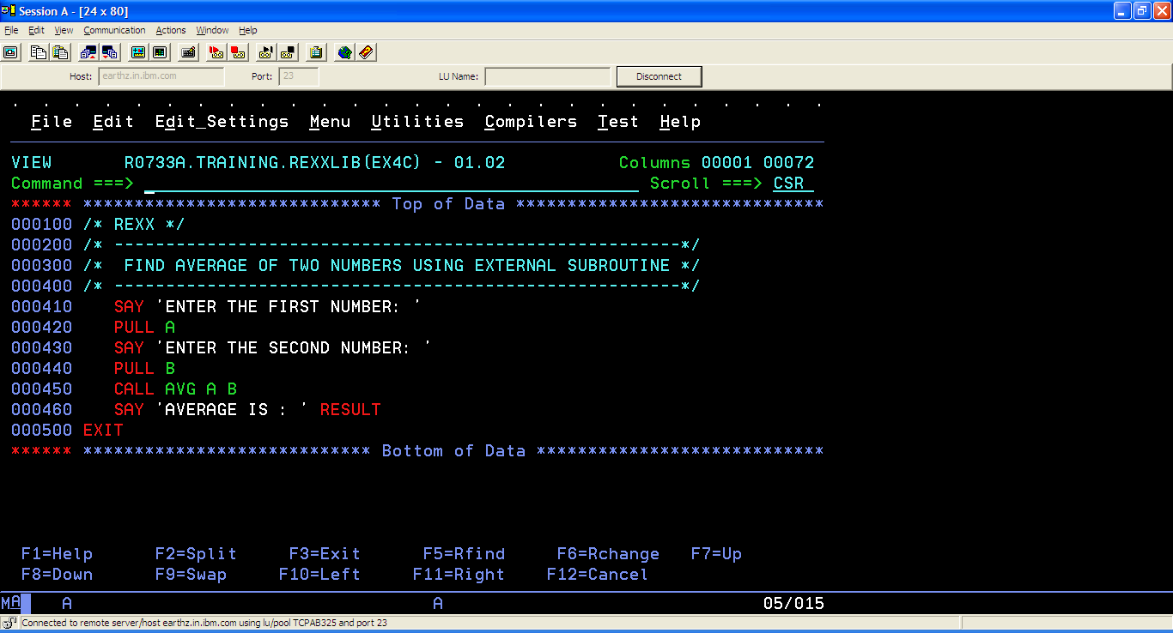

External Subroutine (stored as a different program):

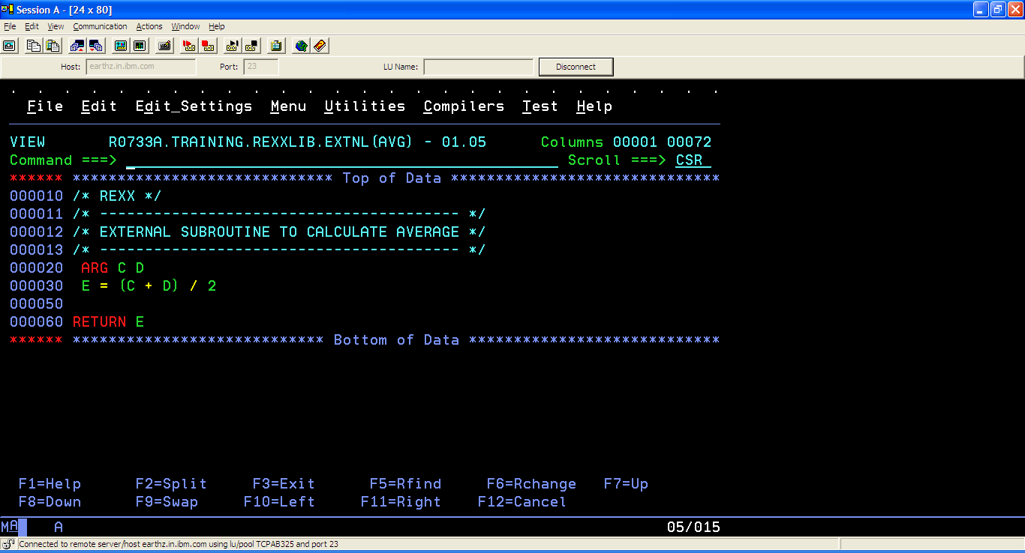

The external program’s source library R0733A.TRAINING.REXXLIB.EXTNL should be allocated to SYSEXEC as follows:

- Get the current SYSEXEC allocation using ISRDDN.
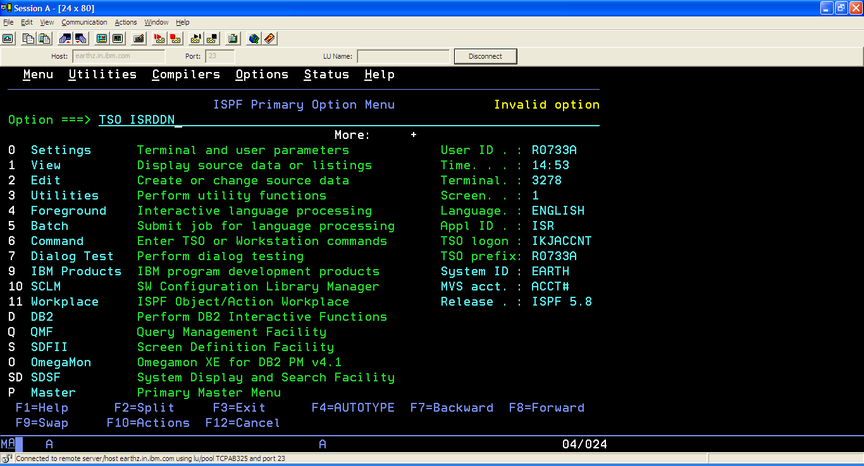

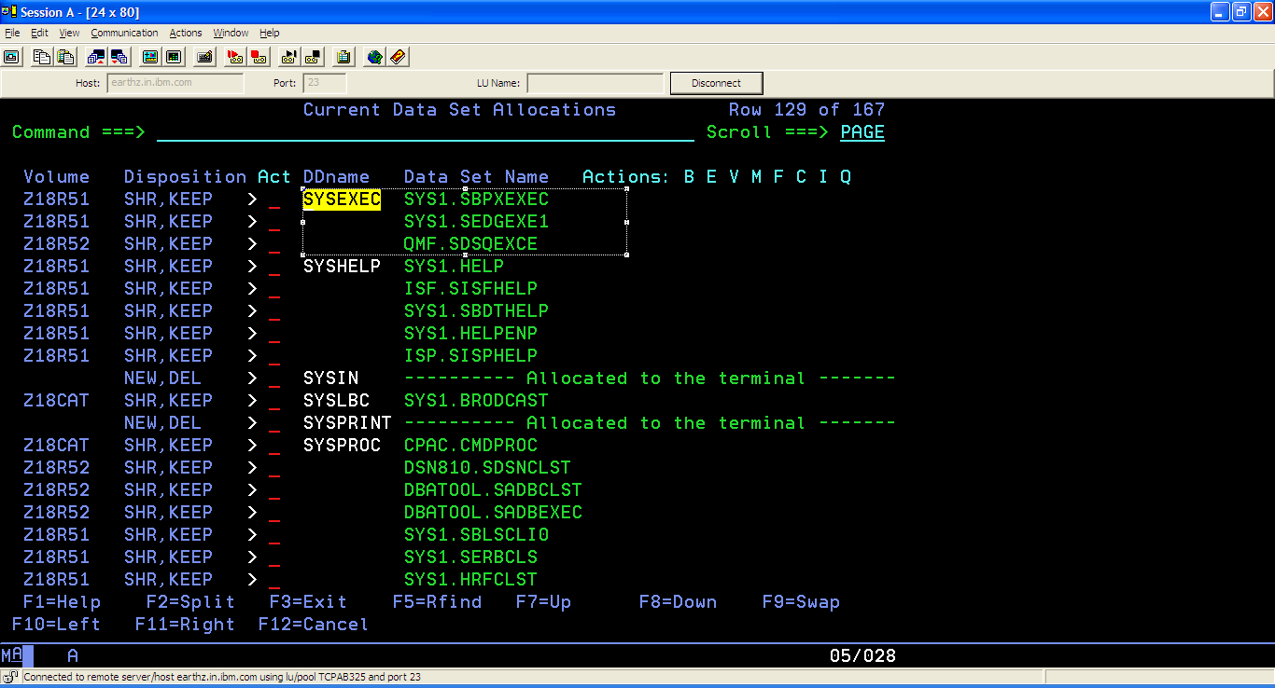

- Concatenate the external subroutine’s source library with the existing libraries of SYSEXEC using the READY prompt as follows:

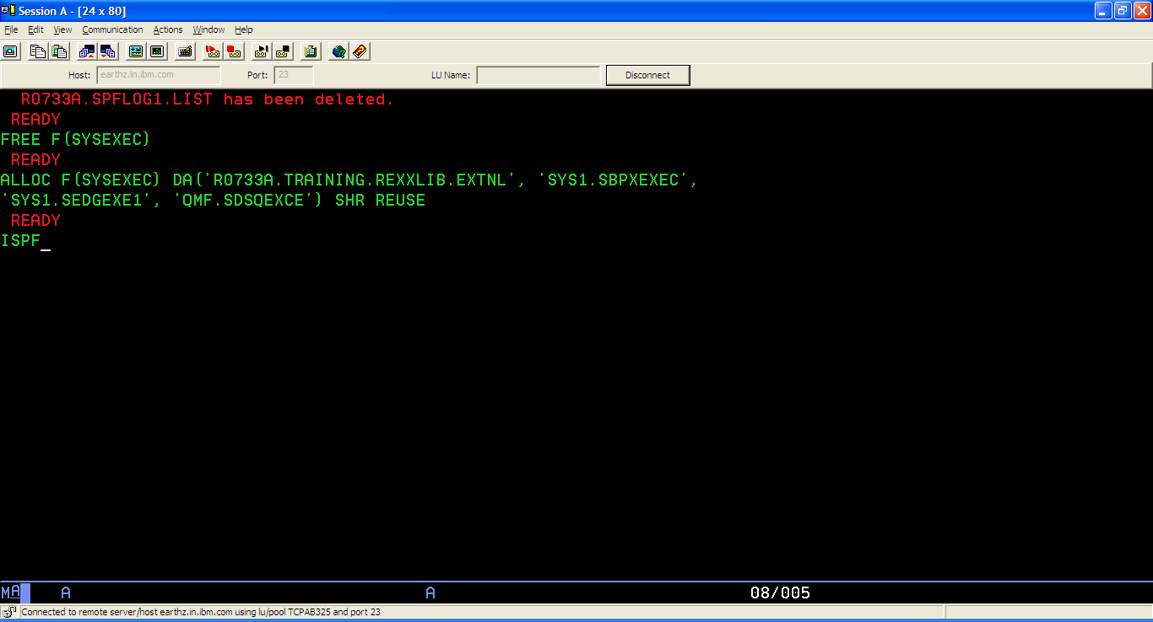

- Press ENTER and check if the external subroutine’s source library is allocated to SYSEXEC using ISRDDN.

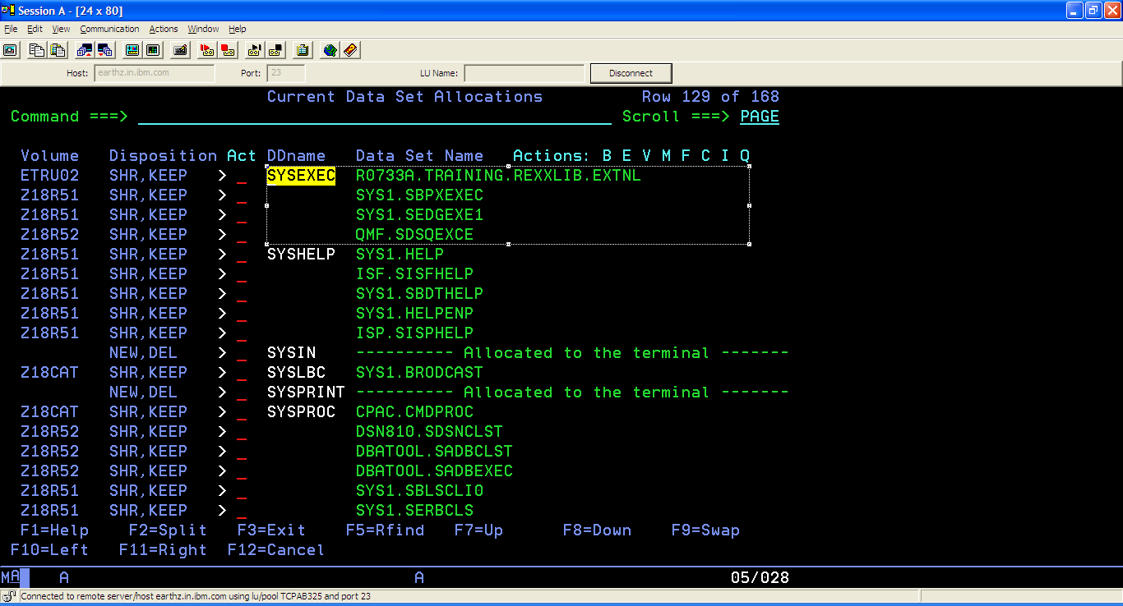

Apart from using the above method with the READY prompt, there is an alternative method using which SYSEXEC can be allocated from the REXX program itself. The alternative method will be discussed in the forthcoming modules.

Once SYSEXEC is allocated with the external subroutine’s source library, the external subroutine can be invoked from the main module as follows:

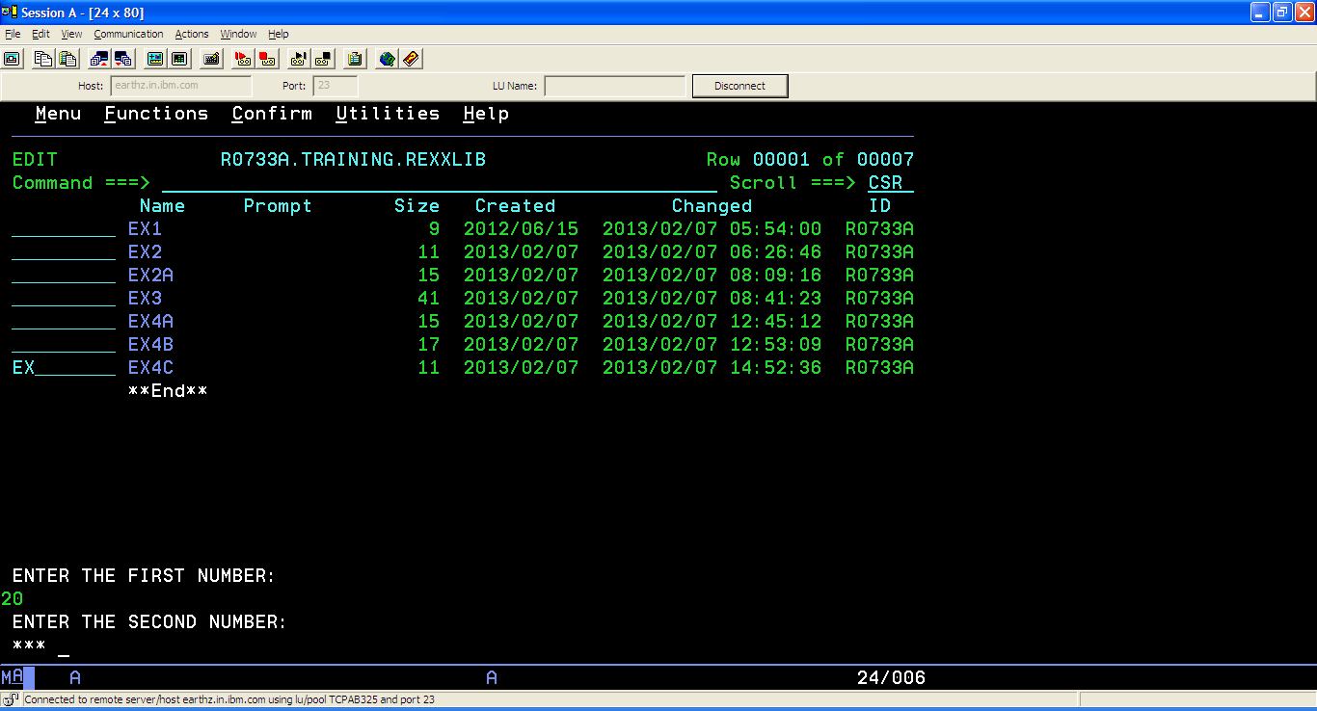

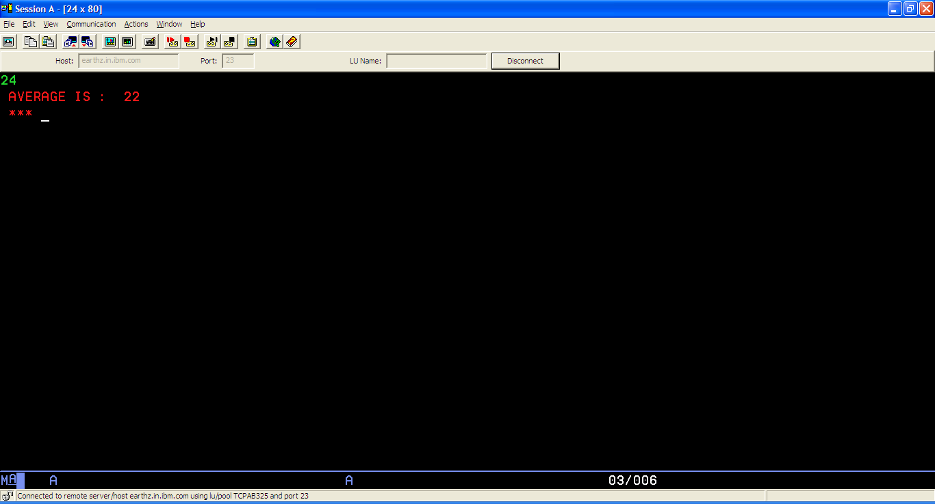

Finding the average of two numbers using an external function:

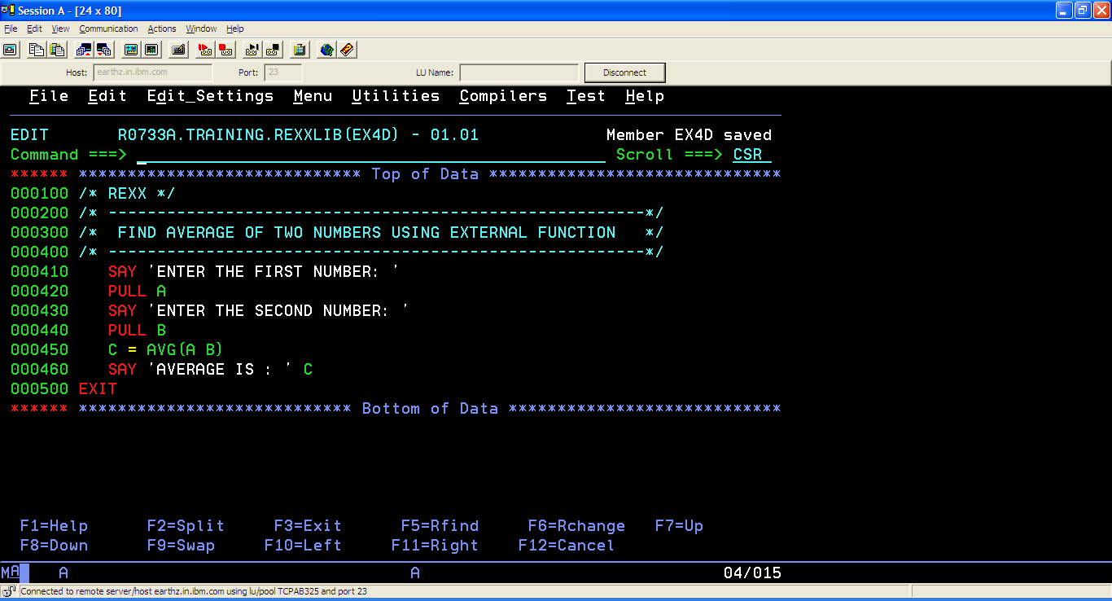

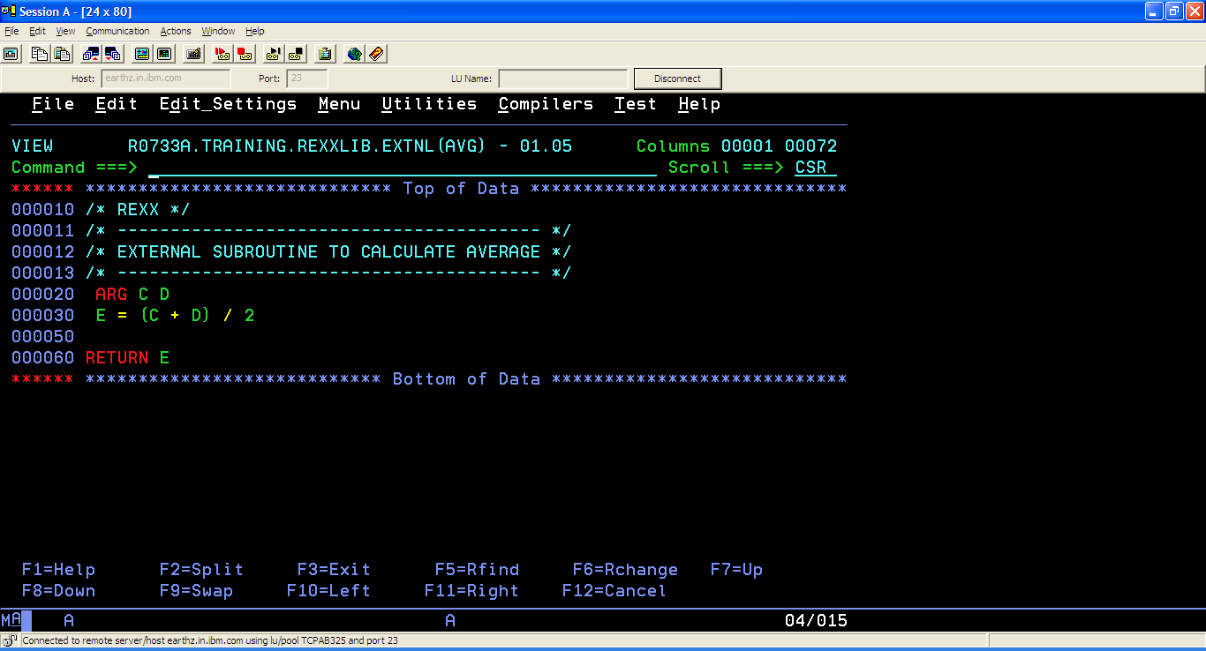

Allocate R0733A.TRAINING.REXXLIB.EXTNL to SYSEXEC with the steps outlined in the previous method (Finding the Average of Two Numbers Using External Subroutine). Then, the main module can be executed to invoke the external function.

